Project Planning Phase
Project Planning Template (Product Backlog, Sprint Planning, Stories, Story points)

Date | 28 February 2026
Team ID | LTVIP2026TMIDS89849
Project Name | dog breed identification using transfer  learning
Maximum Marks | 5 Marks

Product Backlog, Sprint Schedule, and Estimation (4 Marks)
Sprint | Functional Requirement (Epic) | User Story No | User Story / Task | Story Points | Priority | Team Members
Sprint-1 | Registration | USN-1 | User can register using email & password | 2 | High | Team
Sprint-1 | Registration | USN-2 | User receives confirmation email | 1 | High | Team
Sprint-1 | Registration | USN-4 | User can register using Gmail | 2 | Medium | Team
Sprint-1 | Login | USN-5 | User can log in using email & password | 1 | High | Team
Sprint-1 | Prediction | USN-6 | Upload dog image for prediction | 3 | High | Team
Sprint-1 | Prediction | USN-7 | Display breed prediction result | 3 | High | Team
Sprint-2 | Dashboard | USN-8 | View prediction history | 3 | Medium | Team
Sprint-2 | Prediction | USN-9 | Show breed details & info | 3 | Medium | Team
Sprint-2 | Registration | USN-3 | Register using social login | 2 | Low | Team
Sprint-3 | Feedback | USN-10 | User can submit feedback | 2 | Medium | Team
Sprint-3 | Admin | USN-11 | Admin manages users | 3 | High | Team
Sprint-3 | Admin | USN-12 | Monitor system performance | 3 | Medium | Team
Sprint-4 | Enhancement | USN-13 | Improve accuracy & model update | 4 | Medium | Team
Sprint-4 | Enhancement | USN-14 | UI improvements | 2 | Medium | Team

Project Tracker, Velocity & Burndown Chart: (4 Marks)
Sprint | Total Story Points | Duration | Sprint Start | Sprint End (Planned) | Story Points Completed | Release Date
Sprint-1 | 20 | 6 Days | Day 1 | Day 6 | 20 | Day 6
Sprint-2 | 20 | 6 Days | Day 7 | Day 12 | 18 | Day 12
Sprint-3 | 20 | 6 Days | Day 13 | Day 18 | 17 | Day 18
Sprint-4 | 20 | 6 Days | Day 19 | Day 24 | 20 | Day 24

Velocity Calculation
If sprint duration = 10 days
Team velocity = 20 story points per sprint
Average Velocity (AV)
AV = Story Points / Sprint Duration
AV = 20 / 10
Average Velocity = 2 story points per day
This means the team completes 2 story points per day.
Burndown Chart:
A burndown chart shows the remaining work versus time in a sprint. At the beginning of the sprint, the total story points are at the highest level. As tasks are completed daily, the remaining work decreases until it reaches zero at sprint completion. This helps track progress, identify delays, and ensure timely delivery of the project.
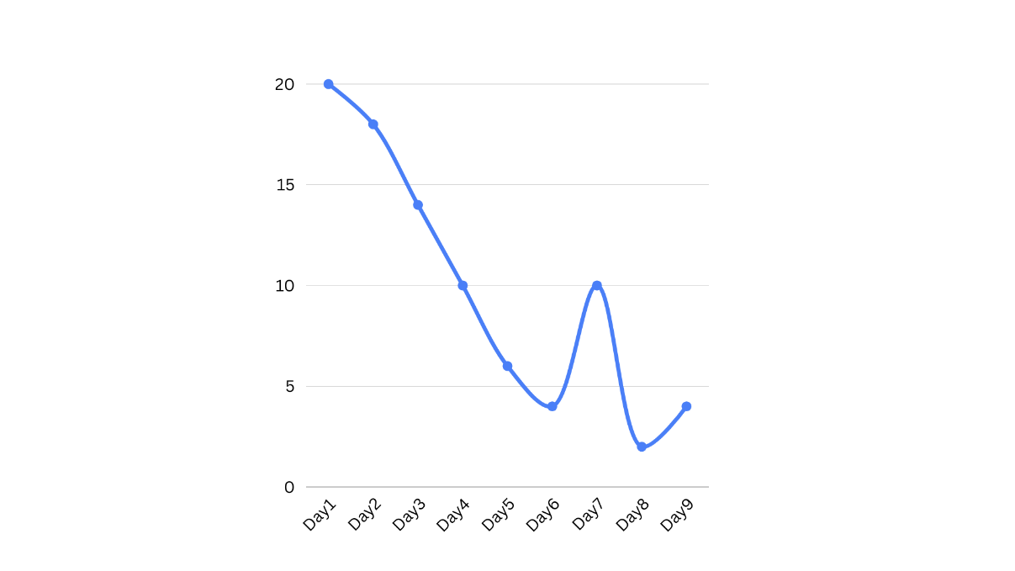
https://www.visual-paradigm.com/scrum/scrum-burndown-chart/
https://www.atlassian.com/agile/tutorials/burndown-charts

Reference:
https://www.atlassian.com/agile/project-management
https://www.atlassian.com/agile/tutorials/how-to-do-scrum-with-jira-software
https://www.atlassian.com/agile/tutorials/epics
https://www.atlassian.com/agile/tutorials/sprints
https://www.atlassian.com/agile/project-management/estimation
https://www.atlassian.com/agile/tutorials/burndown-charts

